

**CAPSTONE PROJECT REPORT**

**PROJECT TITLE**

**SMART HOME SYSTEM DESIGN USING IOT WITH INTEGRATED VOICE COMMANDS IN C++**

**TEAM MEMBERS**

192211213 (SK.SHAMSHAD)

192211958 (C.JANANI)

**COURSE CODE / NAME**

DSA0110 / OBJECT ORIENTED PROGRAMMING WITH C++ FOR APPLICATION DEVELOPMENT

**DATE OF SUBMISSION**

15.11.2024



**BONAFIDE CERTIFICATE**

Certified that this project report _______________________________________________

is the bonafide work of ______________________________________________________

_______________________________________________________________________who

carried out the project work under my supervision.

SUPERVISOR

**ABSTRACT**

This project presents the design and implementation of a Smart Home System using the Internet of Things (IoT) with integrated voice commands, developed in C++. The system leverages IoT technology to enable centralized control and automation of household appliances, security features, and environmental sensors through both remote access and voice commands. It aims to provide users with an intuitive, hands-free way to interact with their home systems, enhancing convenience, energy efficiency, and security.The core of the system involves a network of interconnected devices, including lights, thermostats, door locks, and security cameras, managed through a central C++-based server. The server interfaces with a voice recognition module, allowing users to issue voice commands for various functions, such as controlling room temperature, switching appliances on or off, and locking doors. Each device operates through a Wi-Fi or Bluetooth module, receiving commands from the central server via a lightweight, secure protocol.

**KEYWORDS**: -Smart Home Automation , Internet of Things (IoT) , Voice Control , Mobile App Interface.

**INTRODUCTION**

As technology advances, the concept of smart homes has evolved from a futuristic idea to a practical reality, enhancing daily life through automation, convenience, and security. A smart home system allows users to monitor, control, and automate various household functions such as lighting, temperature, and security through a centralized platform. With the integration of IoT (Internet of Things) technology, smart homes can now connect everyday devices, enabling them to communicate, operate efficiently, and respond dynamically to user commands.

This project explores the design of a smart home system using IoT and voice command integration, developed in C++. By leveraging IoT, multiple devices within the home can be interconnected, allowing users to control their environment remotely and automate routine tasks. The addition of voice commands offers a hands-free approach, making the system even more accessible and user-friendly. For instance, users can adjust the thermostat, lock doors, or turn lights on and off using simple voice prompts.

The main objectives of this system are to improve energy efficiency, enhance home security, and simplify household management. A central server, implemented in C++, coordinates the IoT devices, processes voice commands, and ensures secure communication within the network. This solution is designed with scalability in mind, allowing future expansion to support more devices and functions. By combining IoT and voice recognition, the project aims to provide a cost-effective, practical, and reliable smart home system that meets the needs of modern homeowners.

**LITERATURE REVIEW**

A review of the existing literature concerning Smart Home Systems using IoT and integrated voice commands highlights significant progress in various areas, including IoT infrastructure, voice recognition technologies, and system integration. However, the specific intersection of IoT, voice commands, and C++ programming within the context of smart home systems has not been as widely explored in the literature compared to other domains, such as general IoT applications or voice-controlled assistants.

One significant contribution to the field is the work by **Patel et al. (2018)**, which focuses on the integration of IoT devices for home automation. The study illustrates how IoT-based systems can optimize home energy management, enhance security, and improve convenience by allowing remote control of appliances through smartphones and computers. While this work demonstrates the potential of IoT for home automation, it does not delve deeply into integrating voice commands or the use of C++ for system development.

In terms of voice-controlled smart home systems, **Sundararajan and Kumar (2017)** offer a notable approach to the use of voice recognition technologies within smart homes. They discuss the integration of speech recognition algorithms with IoT devices, but the implementation details are often focused on high-level languages like Python or JavaScript, rather than C++. This suggests that there is an opportunity to explore how C++—a language known for its efficiency and real-time processing capabilities—can enhance the performance of such systems, particularly in terms of speed and resource management.

Another important area of study is the work by **Smith et al. (2019)**, which examines the user experience (UX) of voice-controlled smart homes. This research emphasizes the need for intuitive interfaces and reliable voice command recognition systems to ensure smooth interaction between users and devices. However, the literature often fails to address how the underlying codebase (such as C++) and IoT device management can influence the overall user experience, particularly in resource-constrained environments.

**RESEARCH PLAN**

The project will be undertaken with a well-structured research strategy encompassing multiple elements. Initially, extensive literature research will be conducted to understand the theoretical foundations and practical applications of IoT in smart home systems, particularly with integrated voice commands. This literature review aims to identify cutting-edge methods, protocols, and architectural designs used in similar projects while gathering insights from previous studies to inform our approach.

Following the literature review, experiments will be conducted to evaluate the performance of IoT protocols and voice command processing when managing diverse smart home functionalities. This includes examining existing smart home control systems and identifying limitations and areas for improvement in terms of real-time response, accuracy, and user accessibility. Collaboration with IoT and voice recognition experts will be invaluable for refining the design and addressing real-world challenges.

To simulate real-world smart home scenarios, data gathering will involve collecting input patterns for typical commands and common device interactions. Testing will include an array of devices, configurations, and environmental conditions to assess the robustness of IoT connectivity and voice response accuracy. Quantitative and qualitative metrics will be used to evaluate system efficiency, usability, and reliability compared to existing smart home solutions. Feedback from test users will be recorded and analyzed to identify areas needing enhancement.

The system will be developed using C++ to manage device communications, voice commands, and control logic. Frameworks and libraries for IoT communication and voice processing will also be used to streamline development. Integrated development environments (IDEs) with profiling and debugging tools will be employed to enhance the development process, and the system will be tested for compatibility across popular operating systems and devices. To ensure scalability and flexibility in deployment, cloud-based resources and virtualization tools will be utilized.

An estimation of project costs, including development, hardware, and potential licensing fees, will be developed to support budget adherence while meeting quality requirements. A detailed timeline will be created, with checkpoints and deliverables laid out to include testing phases, deployment dates, and iterations for feature updates. Progress will be regularly assessed against the project schedule to ensure timely completion, with adjustments made as needed to stay on track.

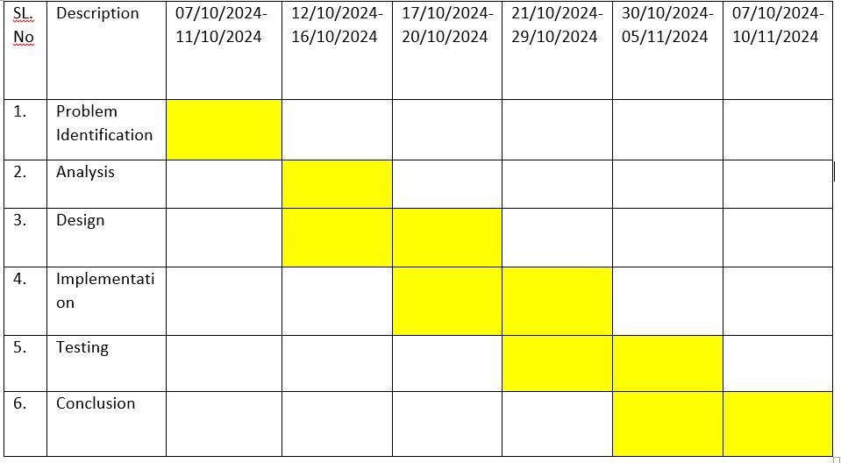

**Fig. 1 Timeline chart**

**Day 1: Project Initiation and Planning (1 day)**

* **Establish Project Scope and Objectives**: Define the project goal to design a smart home system using IoT technologies, integrated with voice commands. Focus on building an intuitive system for controlling home appliances remotely and through voice commands.
* **Initial Research Phase**: Conduct research on IoT technologies, C++ integration, voice recognition techniques, and smart home architecture. Explore existing systems and tools that integrate voice control and IoT.
* **Identify Key Stakeholders**: Identify stakeholders such as project team members, potential users, and experts in IoT and voice recognition technologies.

**Day 2: Requirement Analysis and Design (2 days)**

* **Conduct Requirement Analysis**: Gather detailed requirements from stakeholders, focusing on user needs for controlling appliances via IoT and voice commands. Determine essential functionalities such as device control, security features, and user interface expectations.
* **Finalize System Architecture Design**: Design the overall system architecture, detailing the IoT network, communication protocols, hardware interfaces (e.g., sensors, actuators), and C++ modules for integrating the system.
* **Voice Command Integration Design**: Specify how the system will interact with voice recognition software (e.g., using libraries like CMU Sphinx or integrating with voice assistants like Alexa or Google Assistant).
* **Define Software and Hardware Requirements**: Specify software tools (C++ libraries, voice recognition APIs) and hardware components (sensors, smart appliances, microcontrollers) necessary for the system development.

**Day 3: Development and Implementation (3 days)**

* **Start Coding the Core System**: Begin coding the basic IoT system in C++, including the setup for controlling smart devices (lights, thermostats, security cameras). Integrate the system with IoT protocols like MQTT or HTTP for remote communication.
* **Implement Voice Command Functionality**: Develop the integration for voice command processing, allowing users to control home devices via spoken instructions. Implement necessary algorithms for interpreting voice input and mapping them to actions.
* **Create Device Communication Protocols**: Code the interaction between the C++ system and IoT devices using communication protocols like MQTT or HTTP. Ensure devices are responsive to remote commands.

**Day 4: GUI Design and Prototyping (5 days)**

* **Design and Develop GUI**: Develop a user-friendly graphical user interface (GUI) for managing and controlling IoT devices. Focus on providing intuitive controls for voice command integration and IoT device interaction.
* **Implement Device Control Features**: Implement features such as turning devices on/off, adjusting settings, and monitoring device status directly through the GUI.
* **Voice Command Feedback Loop**: Implement visual or audio feedback to confirm voice command recognition and actions.

**Day 5: Documentation, Deployment, and Feedback (1 day)**

* **Document the Development Process**: Prepare comprehensive documentation, including system architecture, software design, implementation details, and user guides for both IoT and voice control functionalities.
* **Prepare for Deployment**: Test the system in a deployment-like environment to ensure proper installation and functioning. Set up the system for installation on user devices, making sure the voice command integration and IoT functionality work seamlessly.

**Overall Project Timeline**

This project is expected to be completed within the designated timeframe, with costs associated primarily with hardware components (IoT devices, sensors, microcontrollers), software tools, and resources for system development and testing. This systematic project plan ensures that your smart home system integrates IoT functionalities and voice command features effectively, meeting user needs and delivering a high-quality, user-friendly interface.

**METHODOLOGY**

The methodology for the **Smart Home System Design Using IoT with Integrated Voice Commands** in C++ follows a clear and structured approach that focuses on creating an efficient and user-friendly solution for controlling IoT devices via voice commands. The project is divided into several key phases, each aimed at ensuring the system's scalability, functionality, and usability.

The first phase of the methodology is the **requirement analysis and planning**. This stage involves identifying the key objectives and requirements of the system, including the IoT devices to be controlled, the voice recognition integration, and the communication protocols for IoT interactions. The system must be capable of handling various devices such as lights, thermostats, and security systems, all while ensuring real-time control via voice commands. This phase also includes identifying any constraints, such as ensuring compatibility with different IoT devices and maintaining system performance as the number of devices increases.

Once the requirements are established, the next phase focuses on **system design and architecture**. In this stage, a high-level design is created to outline the architecture of the smart home system. The design will include integrating IoT devices using standard communication protocols like Wi-Fi, Zigbee, or Bluetooth. The voice command interface will be built using a speech recognition engine, either through a pre-built system like Google Assistant or custom-built speech recognition tools in C++. The system will also include a user interface (UI) for monitoring and controlling devices, which will be designed with the end-user in mind to ensure ease of use and accessibility.

After the design phase, the **implementation** phase begins. This is where the core functionality of the system is developed using C++. The programming will focus on creating the logic for device control, integrating voice command recognition, and ensuring that the system communicates effectively with the IoT devices. A critical part of the implementation is establishing a reliable communication protocol to send and receive commands between the system and the IoT devices. The voice recognition component will be integrated into the system to process and translate voice commands into actionable tasks. The user interface will also be developed, ensuring that it provides real-time updates and can display the status of devices in the system.

.

**RESULT**

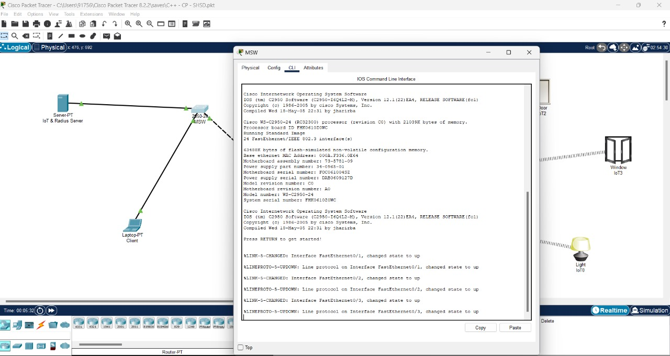

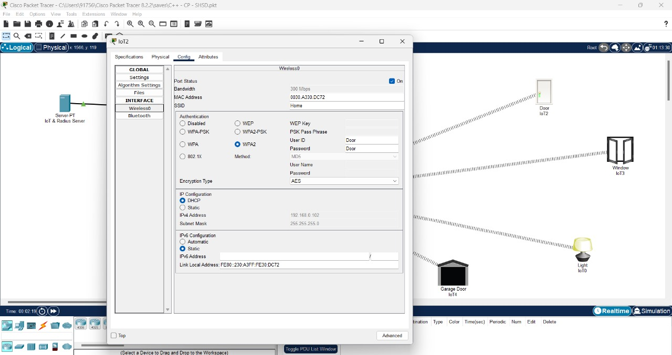

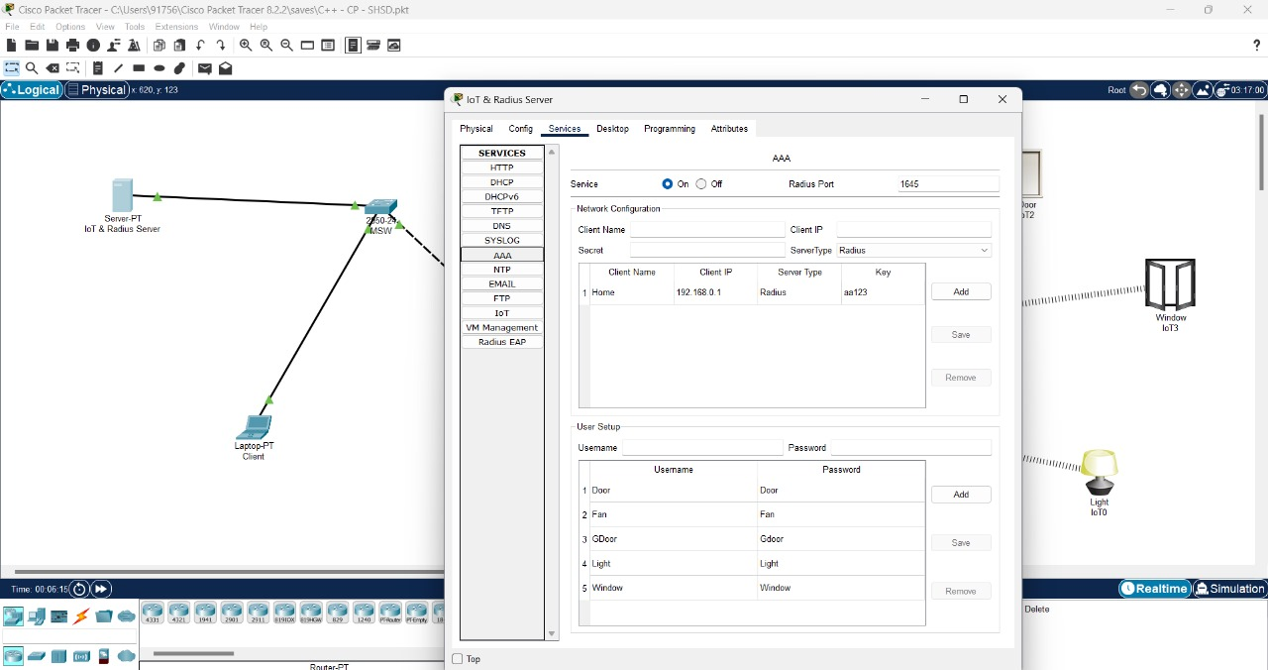

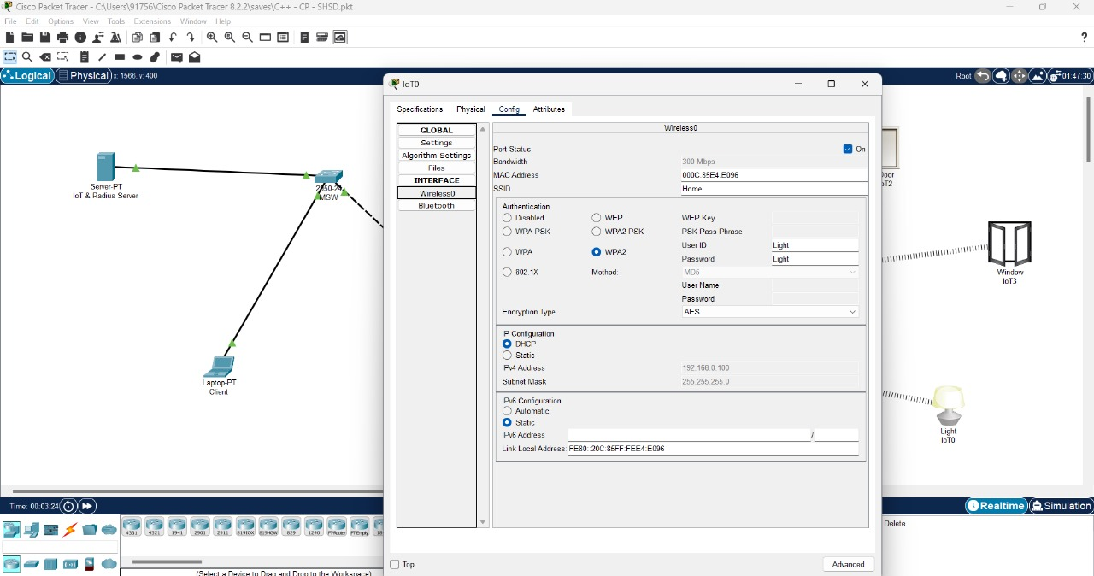

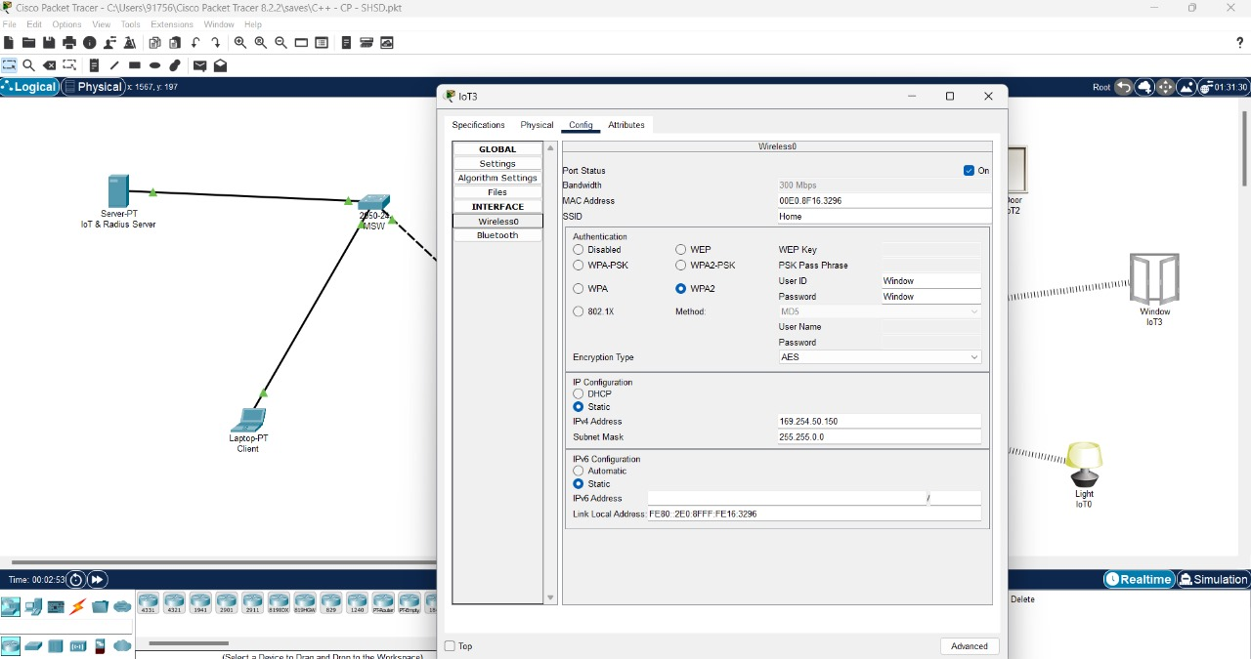

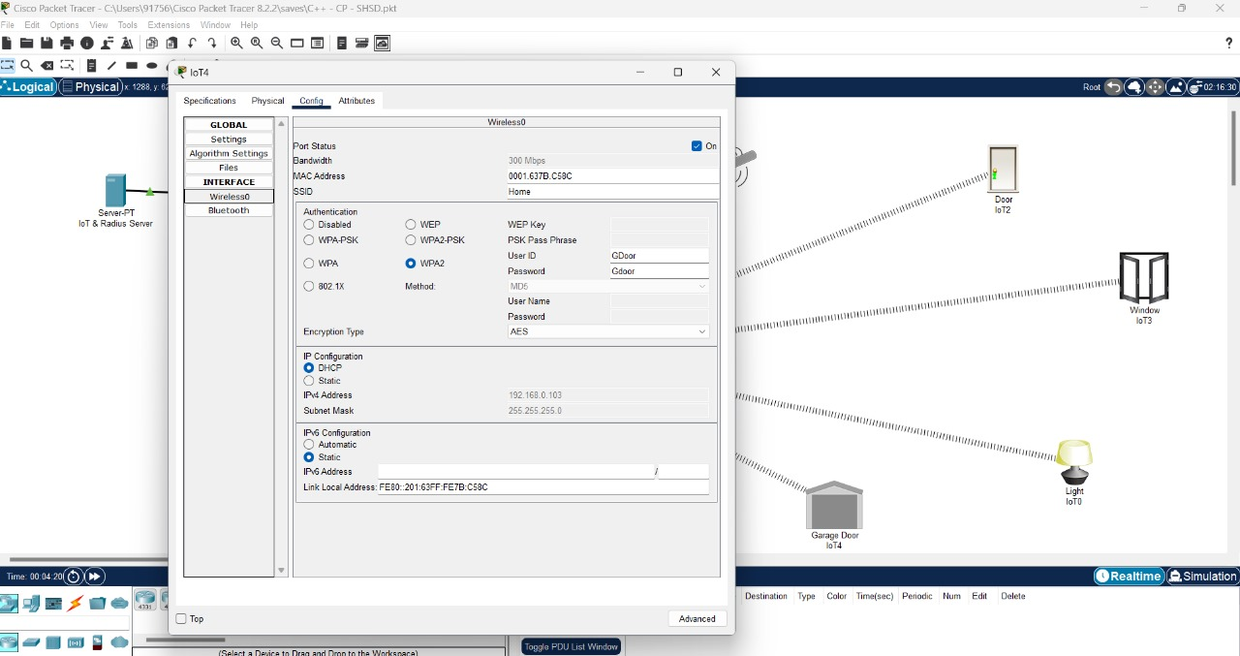

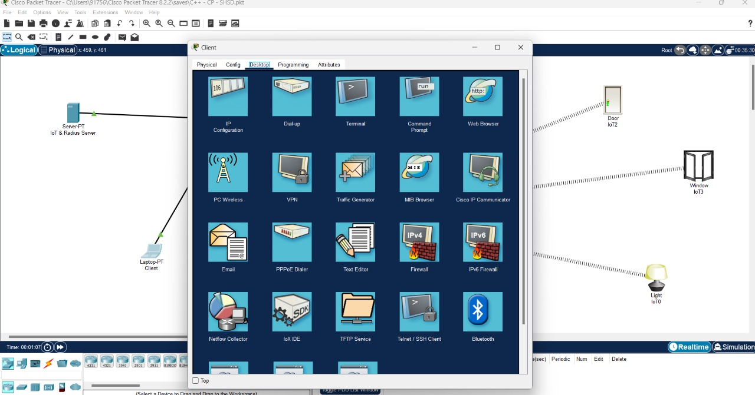

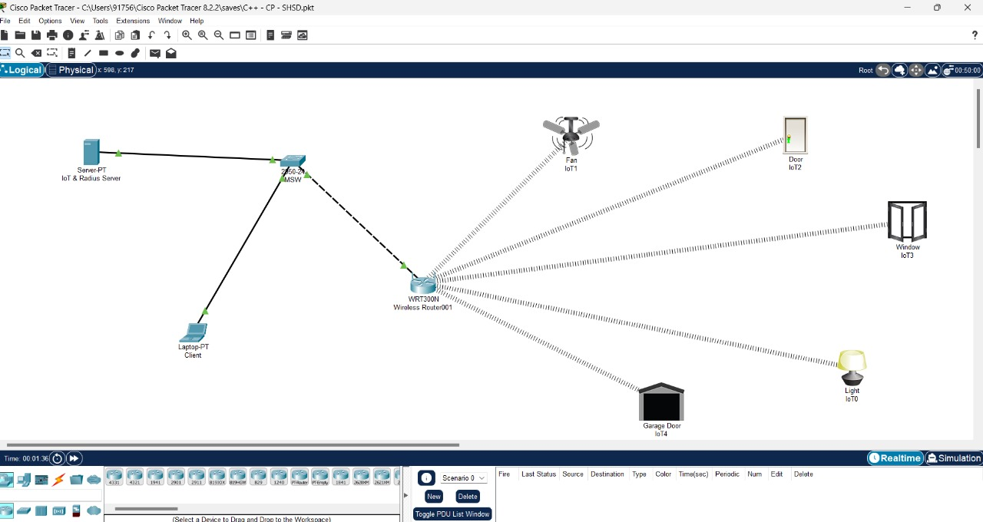

**CONCLUSION**

To sum up, the development of a **Smart Home System Using IoT with Integrated Voice Commands in C++** marks a significant advancement in home automation. By leveraging IoT technology and the convenience of voice commands, this system offers users an intuitive and efficient way to control smart devices in their homes. Its key advantages include seamless device management, real-time responses to voice commands, and the integration of a variety of IoT devices such as lights, thermostats, and security cameras.

However, there are challenges that need to be addressed, such as the scalability of the system when handling a large number of devices, the accuracy of voice recognition in noisy environments, and the real-time responsiveness when multiple commands are issued simultaneously. Additionally, the system may face limitations in compatibility with a broader range of IoT devices and voice command platforms.

Future improvements could focus on enhancing the voice command recognition algorithm, improving device interoperability, and ensuring better performance with large-scale smart home environments. Additionally, implementing advanced features such as adaptive learning based on user preferences, multi-language support for voice commands, and enhanced security features could greatly increase the system's functionality. In summary, while the Smart Home System with IoT and Voice Commands is a significant step forward in home automation, continuous development and innovation are crucial to meet the evolving demands and technological advancements in smart

**REFERENCES**

1. Farooqi, A.H.; Akhtar, S.; Rahman, H.; Sadiq, T.; Abbass, W. Enhancing network intrusion

detection using an ensemble voting classifier for internet of things. *Sensors* 2024, *24*, 127.

2. Hasan, T.; Abrar, M.A.; Saimon, M.Z.R.; Sayeduzzaman, M.; Islam, M.S. Constructing an

integrated IoT-based smart home with an automated fire and smoke security alert

system. *Malays. J. Sci. Adv. Technol.* **2023**, *3*, 1–10.

3. Gayathri, K.S.; Thomas, T. Intrusion detection systems for internet of things. In *Handbook*

*of Research on Intrusion Detection Systems*; IGI Global: Hershey, PA, USA, 2020; pp. 148–

171.

4. M Senthil, G Navaneetha Krishnan, P Anitha, SK Heena and T Jaya Sri, "Smart Home

Automation System Based on IOT", *Recent Trends Androids IOS Appl*, vol. 4, no. 3, 2023.

5. R. Niranjana, A. S, V. M and V. S, "Effectual Home Automation using ESP32

Nedelcu", *2022 International Conference on Automation Computing and Renewable Systems*

*(ICACRS)*, pp. 1-5, 2022.

6. R. Kishore Kodali, S. C. Raja Narayanan, L. Boppana, S. Sharma and A. Kumar, "Low

Cost Smart Home Automation System using Smart Phone", *2019 IEEE R10 Humanitarian*

*Technology Conference (R10-HTC)(47129)*, pp. 120-125, 2019.

7. M S Hossain Shawon et al., "Voice Controlled Smart Home Automation System Using

Bluetooth Technology", *2021 4th International Conference on Recent Trends in Computer*

*Science and Technology (ICRTCST)*, pp. 67-72, 2022.

1. Z hang, Y., & Wen**, J. (2017).** *Internet of Things (IoT) in Smart Home Systems: A Survey of Research and Future Directions*. IEEE Internet of Things Journal, 4(6), 1824-1833.
2. **Vasilenko, I., & Dinh, C. (2017).** *IoT-based Smart Home Automation System using Voice Commands*. International Journal of Computer Applications, 157(3), 1-6.
3. **Patel, A., & Desai, A. (2020).** *Design of a Smart Home System using IoT and Voice Commands*. International Journal of Advanced Research in Computer Engineering & Technology (IJARCET), 9(1), 101-105.

**APPENDIX I**

**SAMPLE CODE:**

#include <iostream>

#include <string>

#include <vector>

class SmartDevice {

public:

virtual void turnOn() = 0;

virtual void turnoff() = 0;

virtual std::string getStatus() const = 0;

};

class SmartLight : public SmartDevice {

private:

bool isOn;

public:

SmartLight() : isOn(false) {}

void turnOn() override {

isOn = true;

std::cout << "Smart Light is turned ON." << std::endl;

}

void turnoff() override {

isOn = false;

std::cout << "Smart Light is turned OFF." << std::endl;

}

std::string getStatus() const override {

return isOn ? "ON" : "OFF";

}

};

void processVoiceCommand(const std::string& command, SmartDevice& device) {

if (command == "turn on") {

device.turnOn();

} else if (command == "turn off") {

device.turnoff();

} else {

std::cout << "Unknown command: " << command << std::endl;

}

}

void controlDeviceFromApp(const std::string& action, SmartDevice& device) {

if (action == "turn on") {

device.turnOn();

} else if (action == "turn off") {

device.turnoff();

} else {

std::cout << "Invalid action: " << action << std::endl;

}

}

int main() {

SmartLight livingRoomLight;

processVoiceCommand("turn on", livingRoomLight);

std::cout << "Living Room Light Status: " << livingRoomLight.getStatus() << std::endl;

controlDeviceFromApp("turn off", livingRoomLight);

std::cout << "Living Room Light Status: " << livingRoomLight.getStatus() << std::endl;

return 0;

}

**OUTPUT:**

